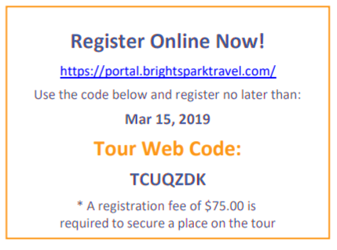  We're planning a fantastic tour to Savannah on October 13 - 15, 2019. This unforgettable learning experience of a lifetime is being coordinated by Brightspark Travel.  Price: $450.00  How Do I Sign Up?  Go online to https://portal.brightsparktravel.com/ for the fastest and easiest way to register.  Any Questions?  Contact customer support at  (877) 545-0070 or email us at customersupport@brightsparktravel.com.  Be sure to include your Tour Web Code, TCUQZDK, when you call. |  | Joshua Wonders  8th grade GA Studies  Joshua.wonders@cobbk12.org  Savannah Trip 2019 |  | Savannah Trip 2019  - Upcoming 8th graders
r
What’s included in the price?  • Quad occupancy for Students (2 beds per room)  • Deluxe Motor coach • Night security each evening at the hotel  • All Admission Fees to Scheduled Activities  • Guided Sightseeing  • Brightspark Staff including 24-Hour Emergency Hotline  • All Taxes and Gratuities  • Lanyards and Emergency Cards for Each Passenger  • Drawstring Backpacks  • 2 Breakfasts, 2 Lunches, 2 Dinners  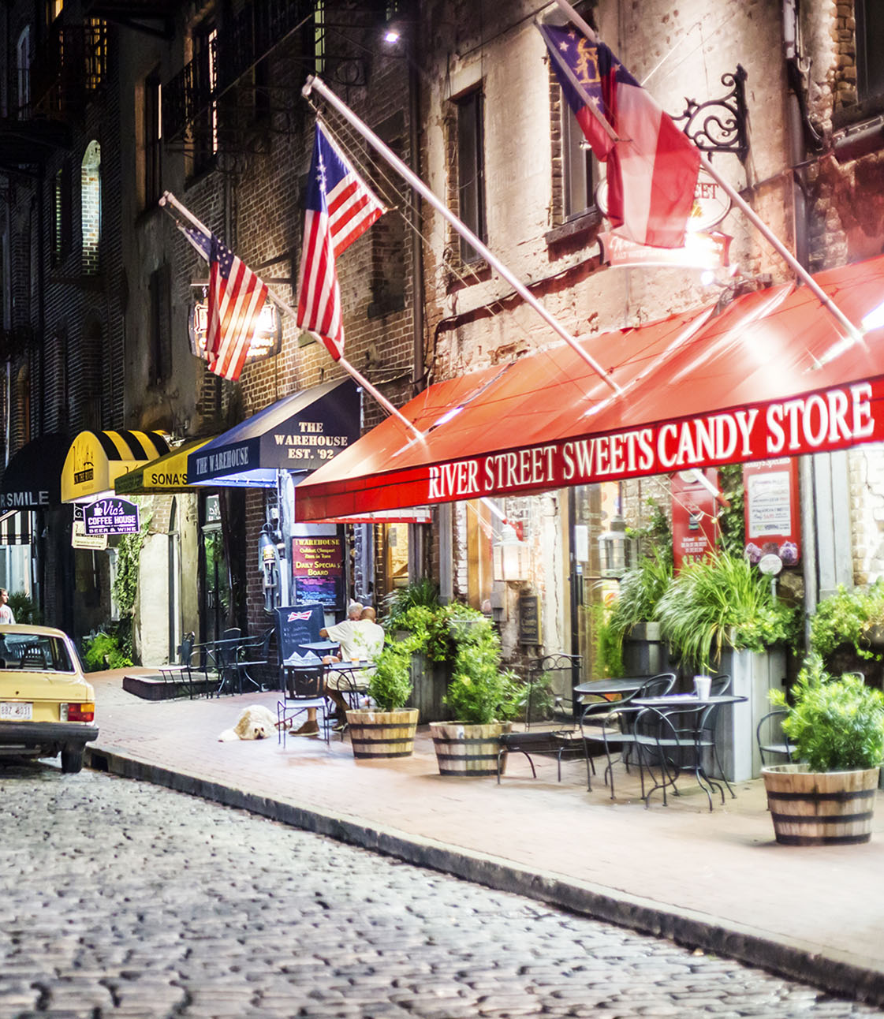  • 2 Nights at hotel |  | 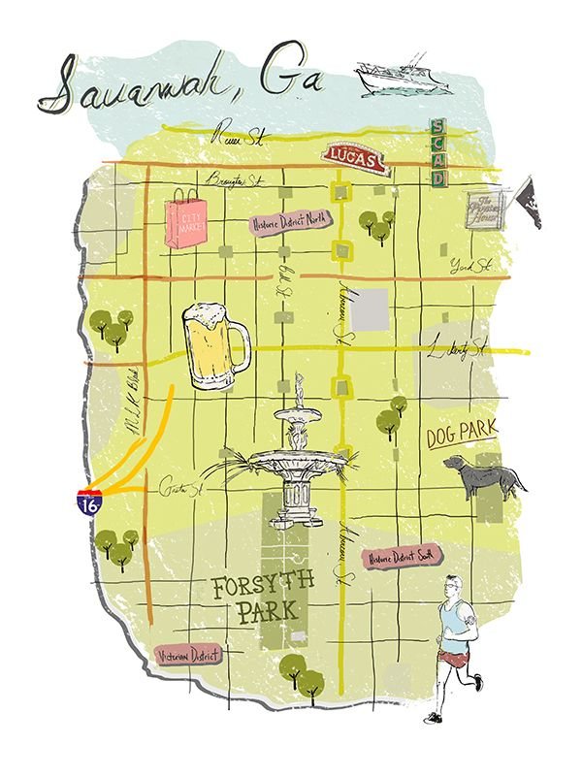WHAT IS REFUND GUARANTEE PROTECTION (RGP)?  For parents, student tours are an investment—but they don’t have to be a risky one. With RGP, parents can cancel their child’s tour at any time, for any reason, and every penny spent on trip payments will be returned to them. Right up until the moment a tour departs, parents are guaranteed a 100% refund on all payments*—including the nonrefundable deposit. *The cost of RGP will not be refunded in case of cancellation. Cost $44.00 |  | Tour Highlights!  • Fort Pulaski self-guided tour  • Walks, Talks & Treks - Tybee Island Marine Science Center  • Massie Center - Savannah Architecture Tour  • River Street - Savannah  • Savannah Riverboat Dinner and Dance Cruise  • Tybee Island  • Savannah History Museum Student Program - Guided Tour  • Andersonville National Historic Site Visit  • SCAD Museum of Art Visit 